**Lab Objective:**

Practice working with lists, stacks, and queues by using them over and over in a simulation of an OS task manager.

**How Code Works:**

Instead of using the predefined stack, queues, and list functions, I built my own. This monstrosity simulates all of the above simultaneously depending on the toggled operation type

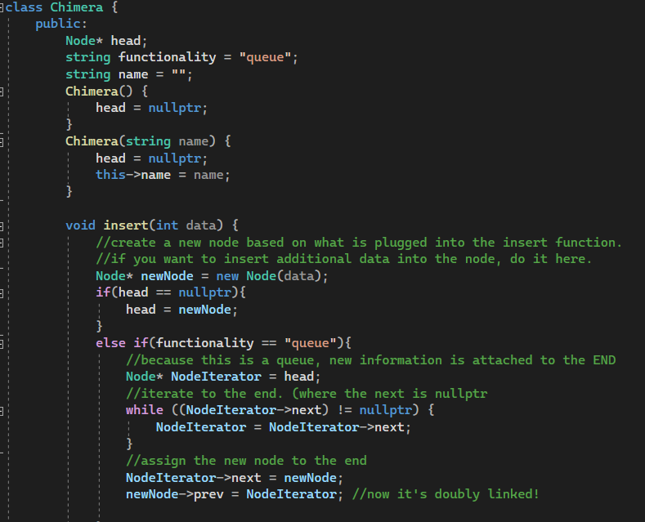

Figure 1 – The queue operation of the Chimera Function, which inserts data at the end. This effectively recreates the ‘enqueue’ function.

Figure 2- The stack operation of the Chimera function, which replaces the head to place the data at the beginning.

Data can also be inserted into the chimera based upon other chimeras, this is done using the extract function.

Figure 3 – the extract operation of the Chimera.

Data can be removed using the pop function of the Chimera, which replaces the head with the next element.

Figure 4 – the pop functions of the Chimera.

Due to the Chimeras modular design, the main function is easy to understand and follows the instructions of the lab without much issue.

Figure 5 – Lab operation part 1

Figure 6 – Lab operation of the Chimera part 2.

The output is this:

Figure 7 – Successful lab output using the Chimera.